CallSwitch Contact centres offer both adhoc reporting and scheduled reporting. Reporting is closely tied to the queue system and the agent versions, so it is important to ensure the CC is configured to utilise Callback agents or Dynamic agents to get access to the full reporting suite.
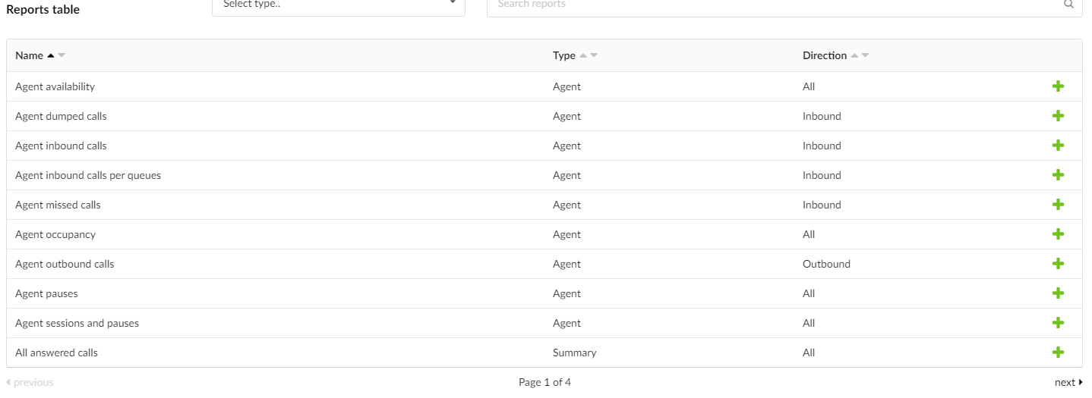

Running Adhoc reports:
Adhoc reports can be run by navigating to "Queues" > "Statistics". Here you can set the types of reports to run, the agents or queues to run them on and the date range for the data you want to see.
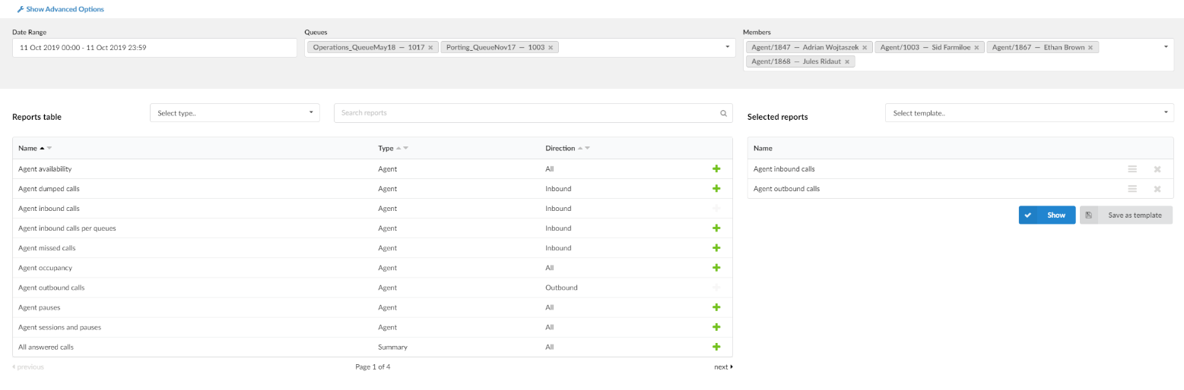
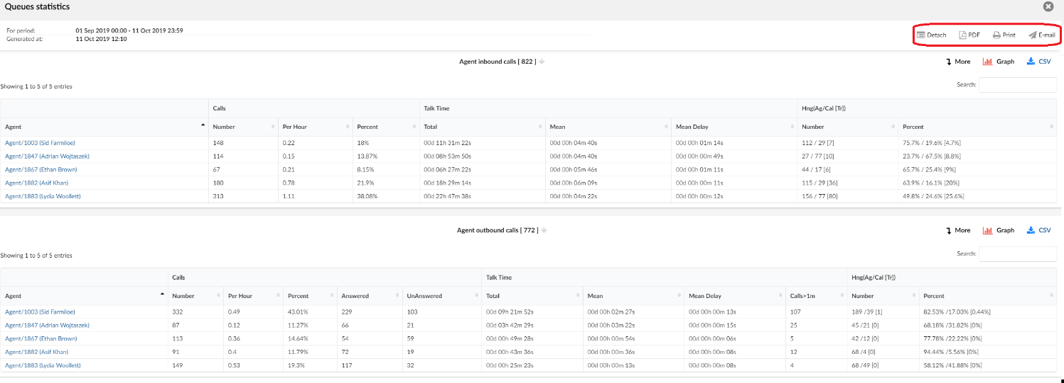

Once the report is run there are some options available:
- Detach: Open the report in a new window.
- PDF: Download a PDF of the active view.
- Print: Print the active view
- Email: Send an email from the platform.

Analysing the data:
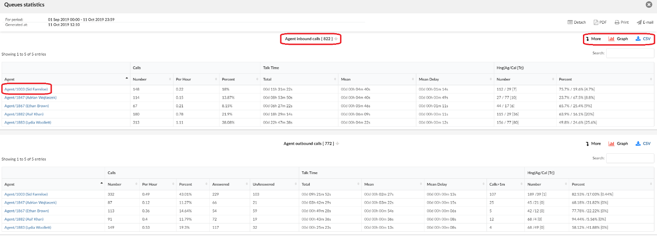
Clicking the report name:
Leave the summary view and show the exact data in the report (Useful for exporting data)
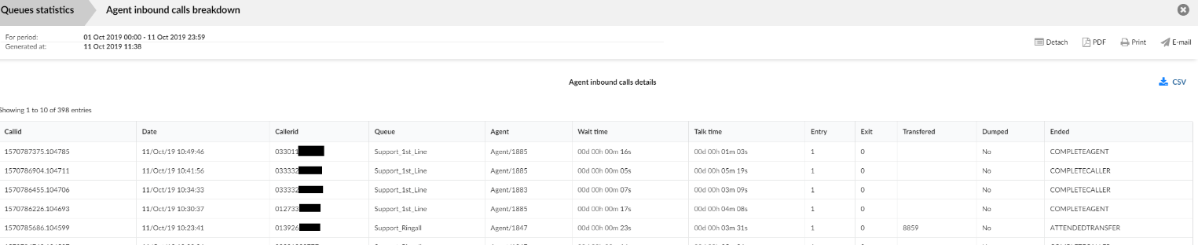
More:
Break down the time zone of the data view (i.e if viewing a month, this will change to weekly, then daily and then hourly.)
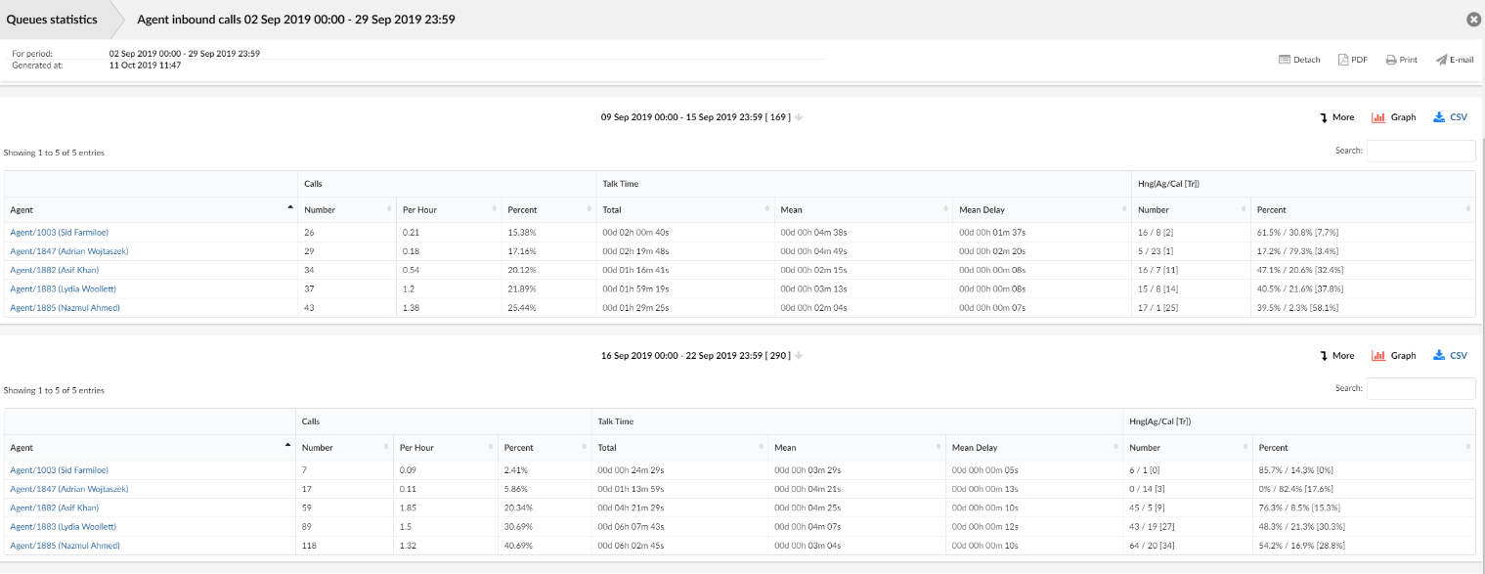
Agent Name:
Show the data for that particular agent, for the active view
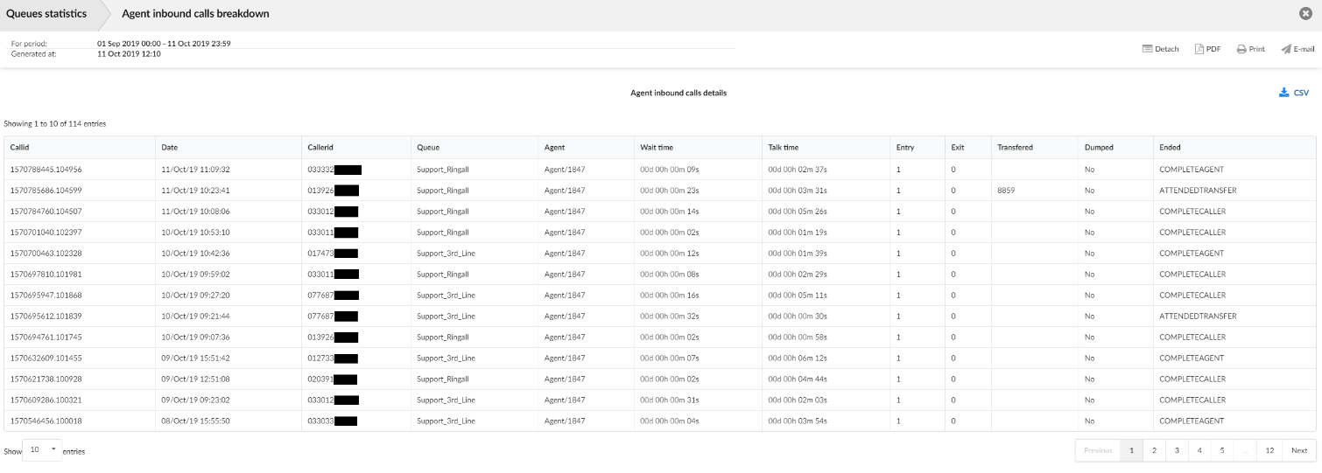

Graph:
Show a visual overview of the active view
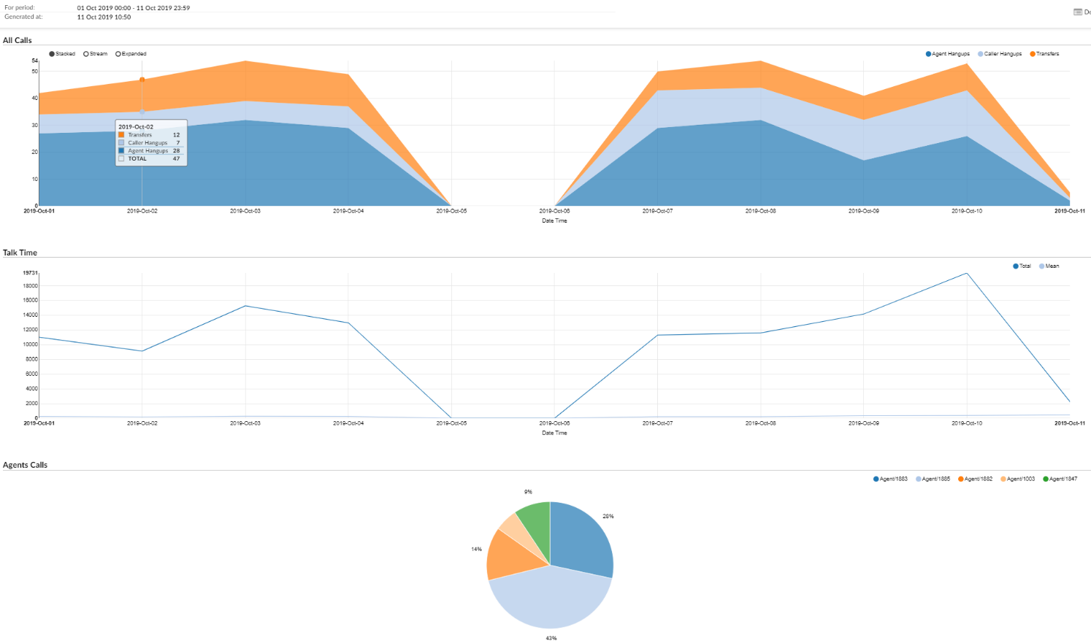
CSV:
Export the active view's data to a CSV spreadsheet
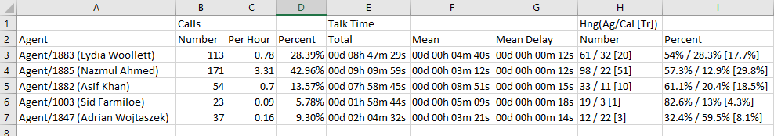

Scheduling reports:
These reports can also be scheduled for email on a hourly/daily/weekly/monthly basis. Once a report has been generated, a summary of the report will be emailed to the address defined and the in depth view (see Analysing Data) can be accessed by pressing the "Show" button, or the link in the report email.
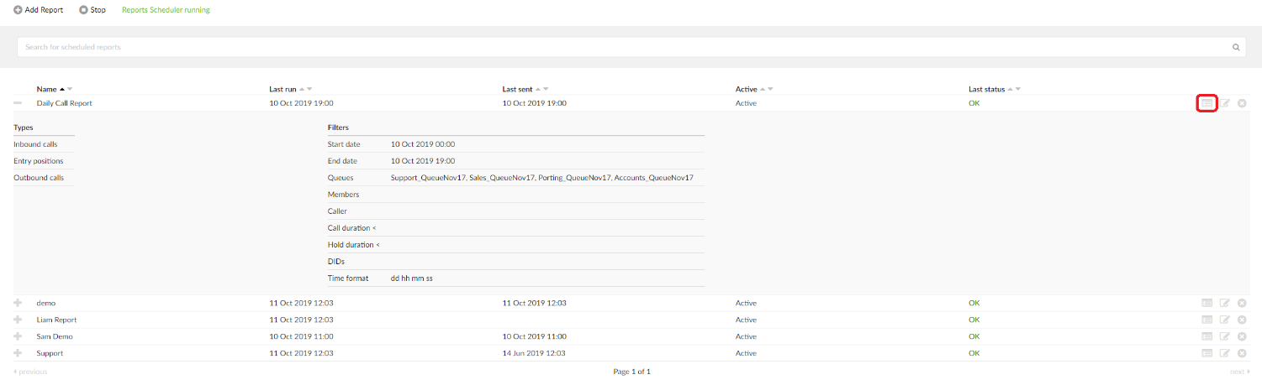
Setting up the reports:
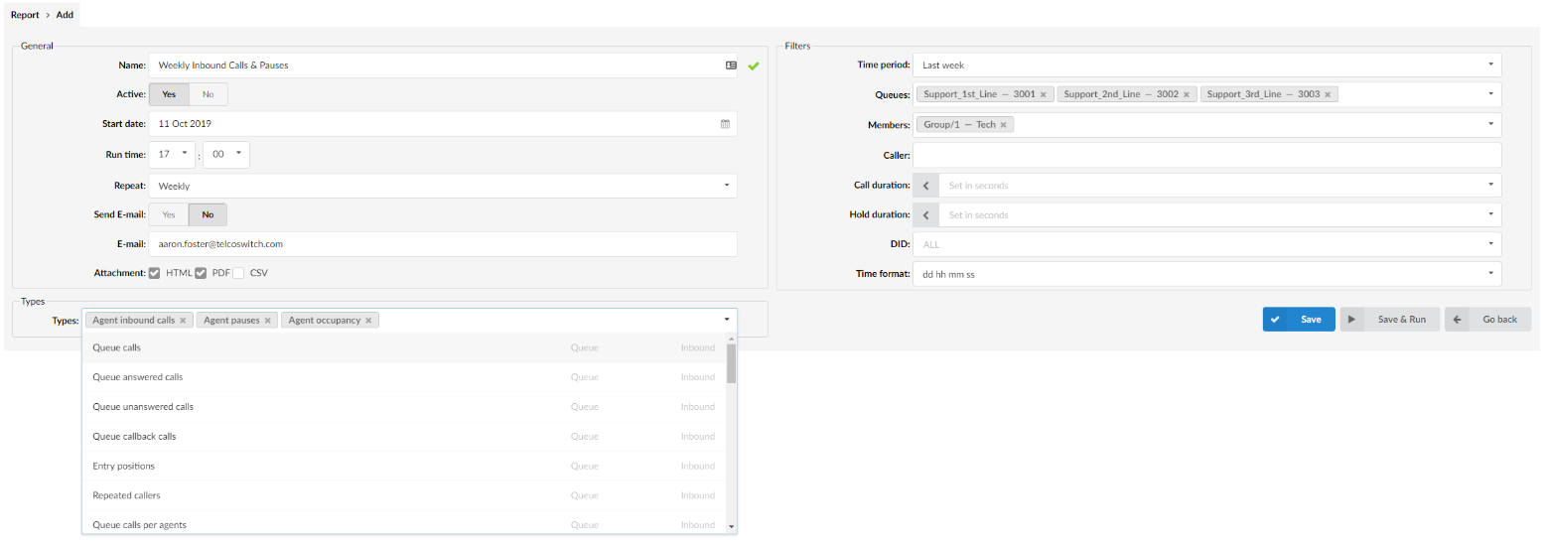
The configurable report fields are:
Name:
The report name to show on the overview and email summary
Active:
Whether the report is actively enabled and scheduled
Start date:
The date to start running the report from
Run time:
Time to generate the report (This will directly tie in with the "Time period" field and will reflect what stats are shown
Repeat:
Repeat interval of the report, can be Hourly,Daily, Weekly,Monthly or Yearly.
E-mail & Attachment:
The Email address to send the report summary to and the kind of summary attachments to send with the notification email.
Time period:
The time period for the data of the report, i,e "last week" will show the weeks data, "Current Day" will show data for up until the time the report is run.
Tip - If you run a report for the "Current Day" at 9am, odds are there isn't going to be any data for that period so it's important to take this field into consideration when configuring reports.
Queues:
What queue's to run the report on
Members:
What agents to run the report on. Ideally these will be either Callback or Dynamic agents, if you choose normal SIP extensions you may not get data that is generated by the queue agent monitoring.
Note: The Queues/Member fields will sometimes clash, if you run an Agent specific report like outbound calls, and then filter it by queue you may see a notification that the filter has been ignored.
Caller:
Can be used to define a callerID to report on, i.e if you wanted to see recurring calls from a specific customers caller ID or anonymous calls.
Call duration:
Greater than/less than toggle for call duration, this can be very useful for checking for calls that have had a long duration.
Hold duration:
Greater than/less than toggle for hold time, this can be very useful for checking for calls that have had a long hold duration (i.e agent unnecessarily leaving callers on hold)
DID:
Show only statistics for calls that came in on a specific number.
Once the report is setup, the "Save & Run" option can be used to generate a report and test it's configured as needed. From then it will run on the specified "Run time" and interval.
reports that can be run on both an ad-hoc & scheduled basis
Agent Reports:
Name | Type | Direction
Agent availability | Agent | All
Agent calls per direction | Agent | Inbound
Agent direct in calls | Agent | Inbound
Agent direct out calls | Agent | Inbound
Agent direct out calls per project | Agent | Inbound
Agent occupancy | Agent | All
Agent pauses | Agent | Outbound
Agent sessions and pauses | Agent | All
All Calls | Agent | All
Direct out answered calls | Agent | Outbound
Direct out calls | Agent | Outbound
Direct out unanswered calls | Agent | Outbound
Project Calls | Agent | Outbound

Queue Reports:
Name | Type | Direction
Agent Dumped Calls | Agent | Inbound
Agent Inbound Calls | Agent | Inbound
Agent Inbound Calls per queue | Agent | Inbound
Agent missed calls | Agent | Inbound
All Answered calls | Queue | Inbound
All calls | Queue | Inbound
All unanswered calls | Queue | Inbound
Distributions for all calls per day | Queue | Inbound
Distributions for all calls per day of month | Queue | Inbound
Distributions for all calls per day of week | Queue | Inbound
Distributions for all calls per hour | Queue | Inbound
Entry positions | Queue | Inbound
Queue answered calls | Queue | Inbound
Queue callback calls | Queue | Outbound
Queue calls | Queue | Inbound
Queue calls per agents | Queue | Inbound
Queue unanswered calls | Queue | Inbound
Repeated callers | Queue | Inbound
Service level agreement | Queue | Inbound
Service level agreement inclusive | Queue | Inbound

