Reset Gigaset BASE station to Factory defaults: N510, N720
- Turn off the device.
- Hold down the “Connect” button on the base.
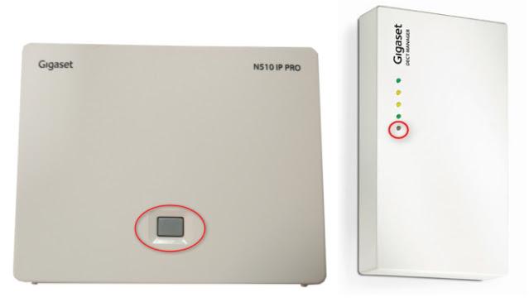
- Power on the device while keeping the “Connect” button pressed and wait 15 seconds until the “Connect” button start to blink fast.
- Release the “Connect” button and power off the device.
- Your DECT system has been successfully reset

Reset Gigaset Handsets to Factory defaults: R650H Pro
- Press the “Menu” key.
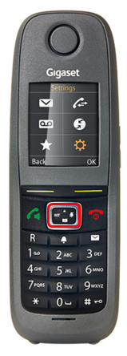
- Navigate to “Settings” → “System” → click “Yes” to reset settings.

