If requested to do so you can factory reset a Yealink T4 series telephone as follows

Press and hold the OK button (usually located as shown in picture below)
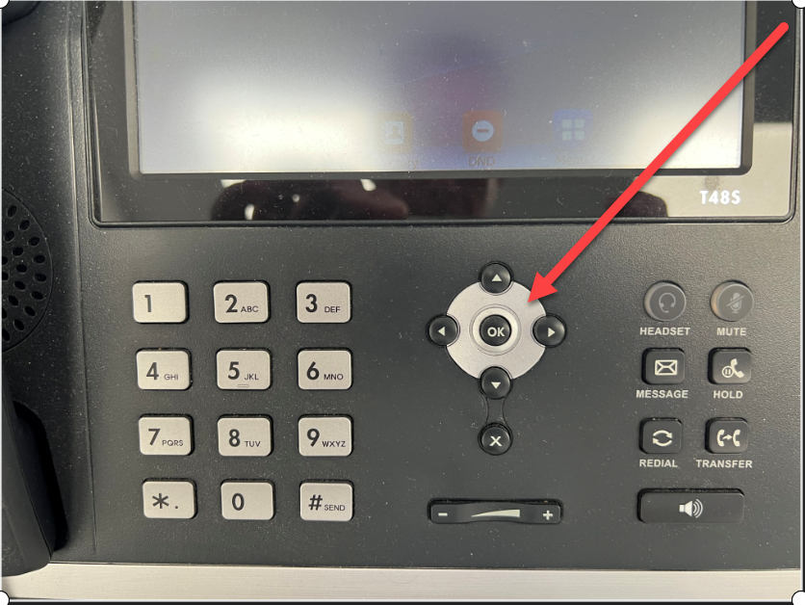
You will get the message on screen…. “reset to factory settings” … OK this and the telephone will reboot (possibly more than once) and this can take several minutes

The telephone settings should now be updated and the telephone ready to use

