The CallSwitch Supervisor edition contains the base version of the CallSwitch soft client, with the addition of the supervisor panel. The supervisor panel gives the supervisor the tools to influence agents, i.e log them out or put them into paused statuses, it also gives supervisors access to overview queue statistics and inbound Wallboards.

Supervisor Panel:
All of the supervisor functions are performed via the supervisor panel, the supervisor panel can be found on the buttons at the top of the application.
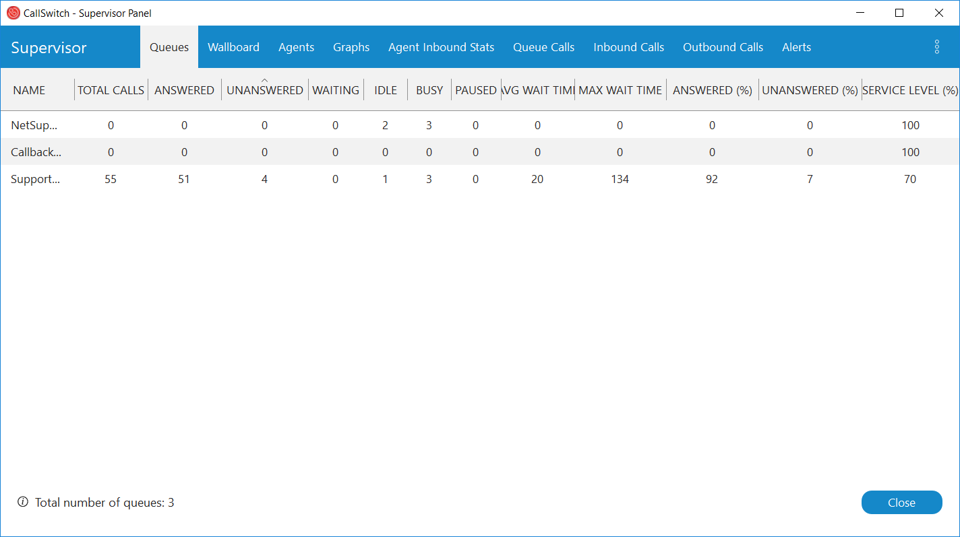
The wallboard will show various inbound statistics for the Queue's. Wallboard's can be set up for multiple queue's and can be configured to perform a "slide show" where the queue's selected are rotated after a customisable amount of time.
Fields on the wallboard can be set to change colour based on the preferences configured under the "threshold" tab.
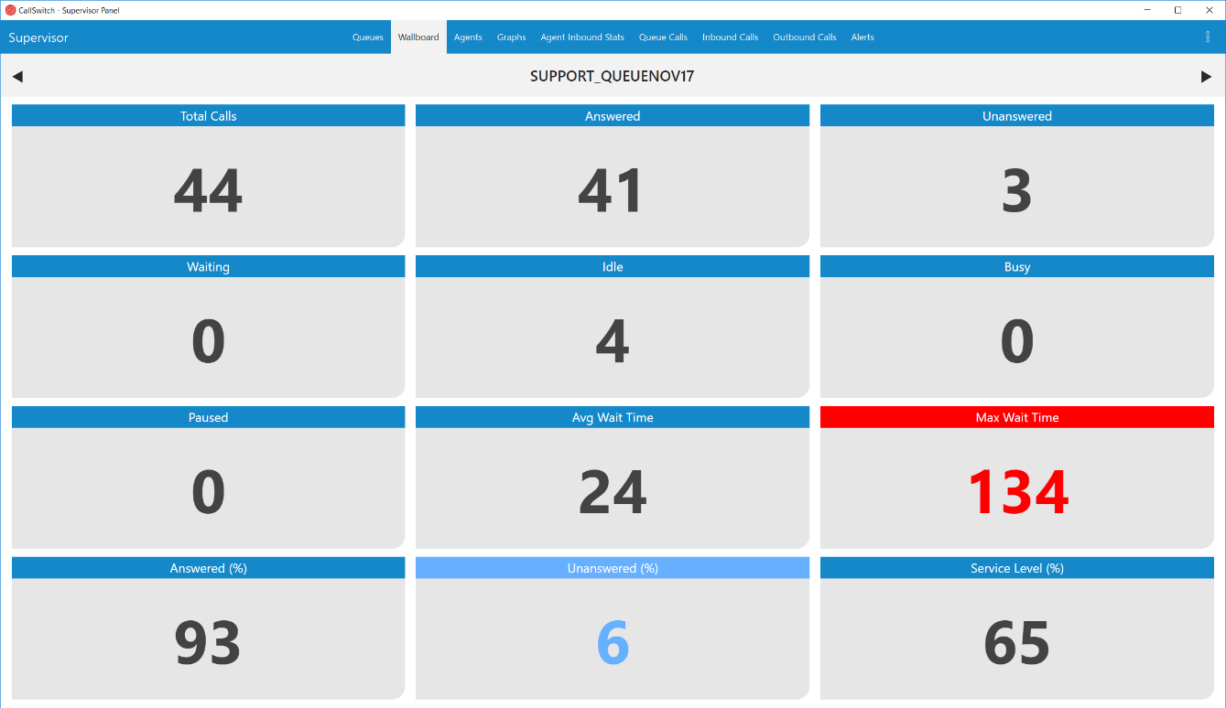
Configurable thresh-holds:
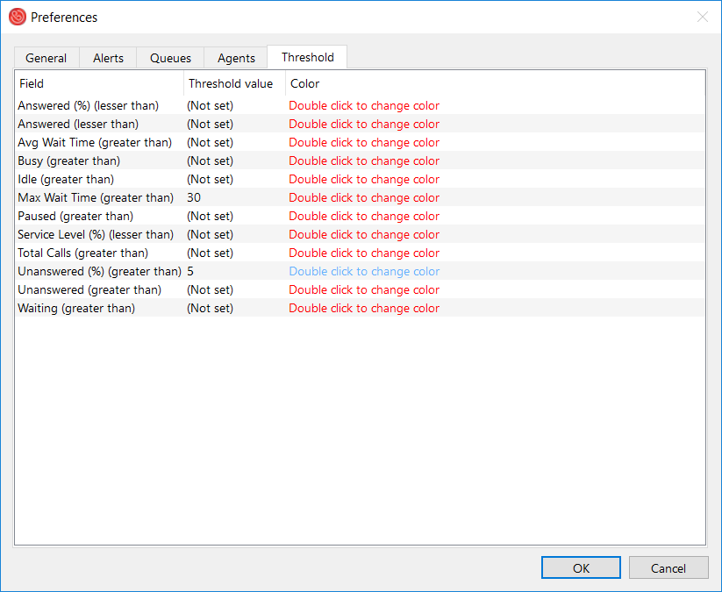

Queue Calls
The queue call panel will show calls that are actively in the queuing system and some general stats such as the position that they're in and the expected answer time, they'll from here a supervisor can take the call, transfer the call directly to an agent or monitor the call.
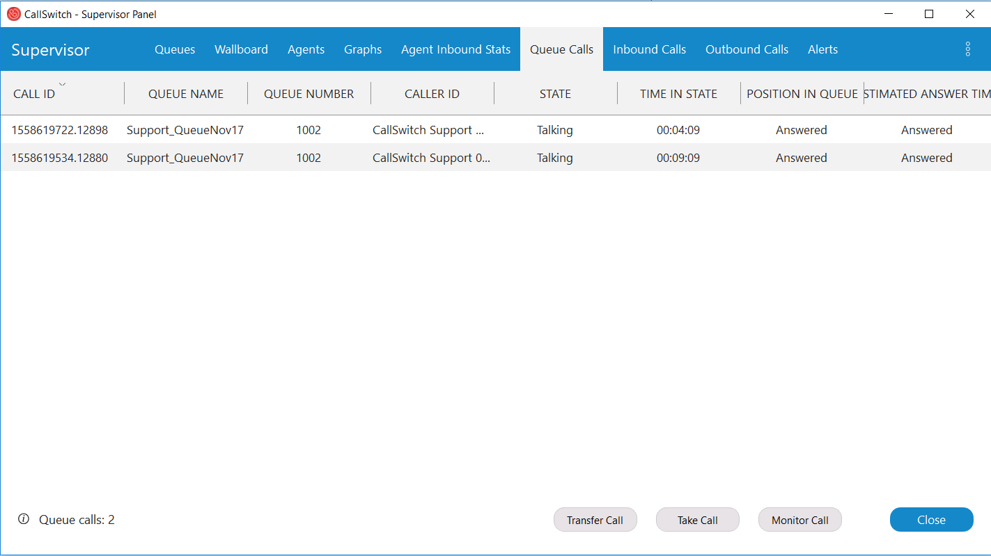
The Agent overview can be used to see the active status of Agents, i.e. whether they are on a call, idle in the queue or in a paused state.
From the Agents panel, a supervisor can influence an agent by clicking on the agent's name. From here they can monitor an active call, transfer an active call to another extension or put an agent in a pause state or log them out.
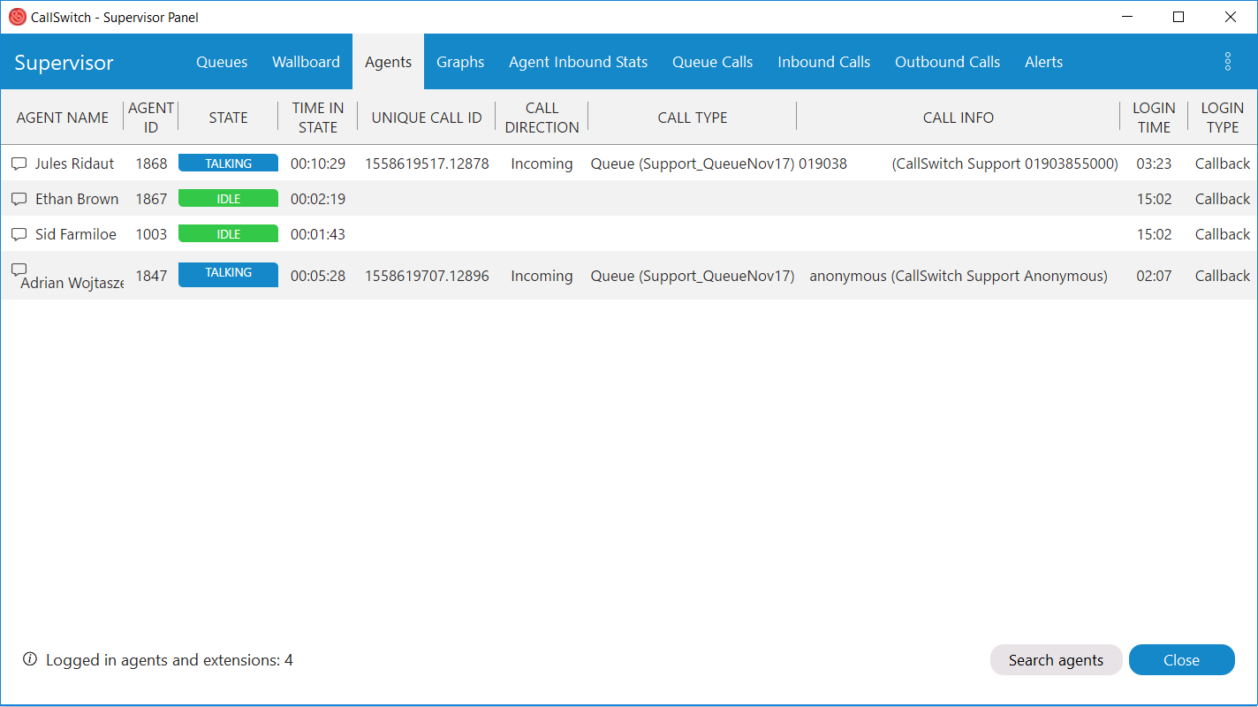
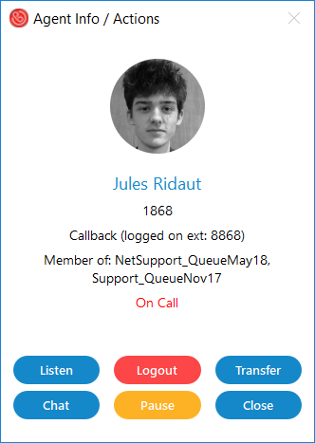
Inbound Calls:
The inbound call panel show's all concurrent inbound calls, from here an agent can transfer the call away from the agent.
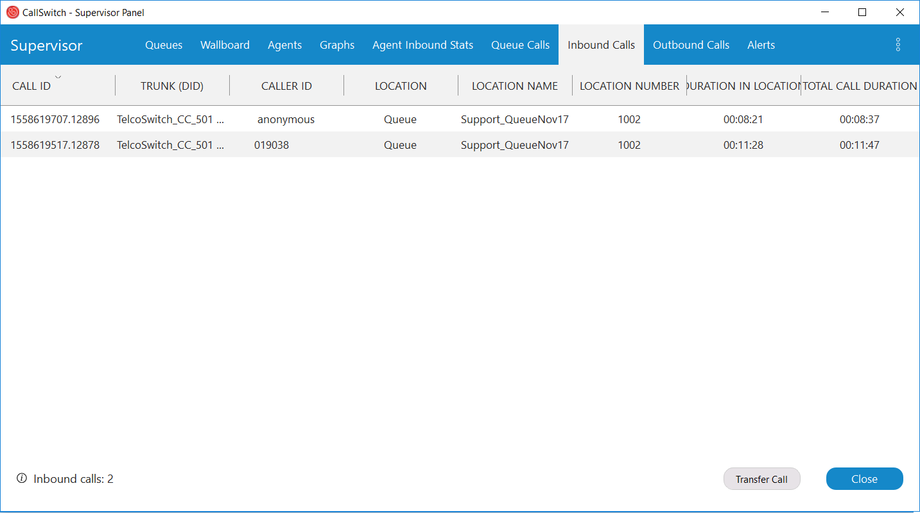

Outbound Calls:
The outbound call panel will show current calls that agents are making, from here a supervisor can transfer the call away, take the call, Monitor or hang up the call.
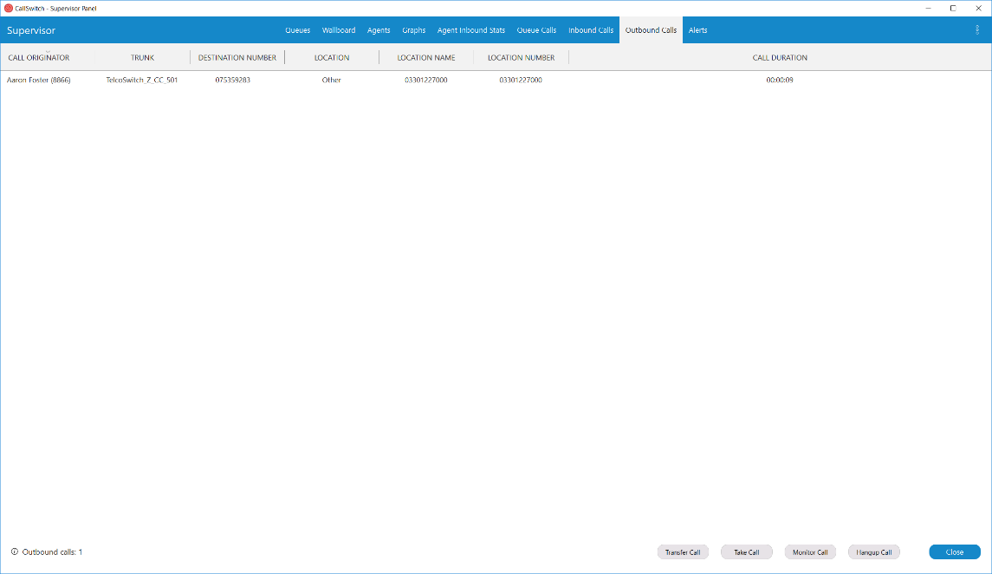

Preferences
The information visible in these sections, such as agents visible and what queue's to monitor can be defined in the preferences of the supervisor panel.
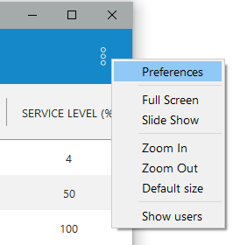

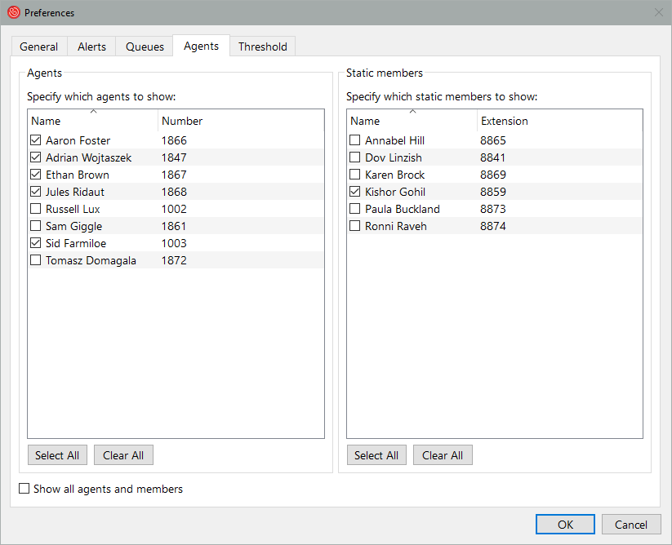

Alerts
The supervisor panel can be configured to popup with alerts based on certain criteria, such as if an agent has been on a call for too long, or too many agents are paused at one time. These alerts will be present in the alert panel, they can also be set up to pop up on the screen or play an audio prompt.
